Full Body Picture
معلومات شخصية Information Personal
Nationality | {nationality} |  | اﻟﺟﻧﺳﯾﺔ
Date of Birth | {dob} |  | ﺗﺎرﯾﺦ اﻟﻣﯾﻼد
Address | {address} |  | اﻟﻌﻧوان
Marital Status | {maritalStatus} |  | اﻟﺣﺎﻟﺔ اﻻﺟﺗﻣﺎﻋﯾﺔ
No. of Children | {numberOfChildren} |  | ﻋدد اﻷطﻔﺎل
Height/Weight | {height} | {weight} | اﻟوزن واﻟطول
Education Qualifications | {educationLevel} |  | اﻟﻣﺳﺗوى اﻟﺗﻌﻠﯾﻣﻲ
Tel. Number | {phone} |  | رﻗم اﻟﺗواﺻل

خبرات سابقة Experience Overseas
Country | Period | Date
{expCountry} | {expPeriod} | {expPosition}

المهارات Skills
Cooking | {skillCook} | اﻟطبﺦ | Baby  Sitting | {skillBaby} | اﻟﺗﻌﺎﻣل ﻣع اﻷطﻔﺎل
Washing | {skillWash} | اﻟغﺳﯾل | Sewing | {skillSew} | اﻟﺧﯾﺎطﺔ
Cleaning | {skillClean} | اﻟﺗﻧظﯾف | Driving | {skillDrive} | ﺳﺎئق

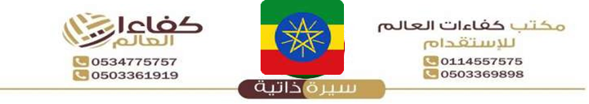
{%facePhoto} | Reference Number | {refNumber}
 | Full Name | {fullName} | اﻻﺳم
 | Religion | {religion} | اﻟدﯾﺎﻧﺔ
 | Position Desired | {position} | اﻟوظﯾﻔﺔ
 | Salary | {salary} | اﻟراﺗب
 | Age | {age} | اﻟﻌﻣر
 | Sex | {gender} | اﻟﺟﻧس
معلومات الجواز Information Passport
Number | {passportNumber}
Issue Date | {issueDate} | اﻹﺻدار
Expiry Date | {expiryDate} | اﻻﻧﺗﮭﺎء
Issue place | {issuePlace} | اﻹﺻدار
Next of Kin name | {emergencyName} | ﺧص
Next of Kin  number | {emergencyPhone} | ﻘرﯾب
{%fullBodyPhoto}

Languages |  | اﻟﻠغﺎت
اﻹﻧﺟﻠﯾزﯾﺔ English |  | Arabic | اﻟﻌربﯾﺔ
Good | {english} | {arabic} | ﺟﯾد
Fluent | NO | NO | ﻣﻣﺗﺎز

Remarks: SHE IS HARDWORKING, NEAT, ORGANISED, SMART, DISCIPLINED, CARING, HAS A GOOD ATTITUDE, SPEAKS GOOD ENGLISH AND LOVES TAKING CARE OF CHILDREN.

